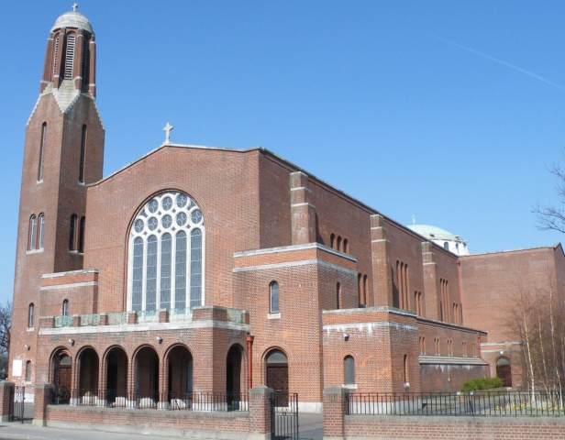

**Welcome Fr. Joe!**

**Archbishop Martin has appointed Fr Joe Mullan as Administrator of Clonskeagh Parish. Fr Joe will continue as Parish Priest of Rathgar. We warmly welcome Fr. Joe and we hope that he is not too heavily burdened with these additional responsibilities. We pray that his ministry will be fruitful and blessed in Clonskeagh Parish.**



**Parish Office**

The Parish Office is open Monday, Wednesday & Friday from 9.30am until 12noon.

*(Closed on Tuesday and Wednesday.)*

from 9.30am until 11am Monday – Saturday & from 9.30am – 12.30pm on Sunday.

**Parish News & Announcements:**

**Special Notice for Mass in Clonskeagh**

As and from this coming **Monday, 20th November**, 10am **Mass will be celebrated in St Joseph's every** **Monday** **to** **Saturday** **morning** (except for funerals).

Entrance will only be through the main church as the door at St Joseph's will be closed to keep out drafts and preserve the heat.

**Diary for this Week:**

**Saturday 18 August  - 20th Sunday in Ordinary Time**

* ***6.30pm Vigil Mass for Peter Kelly (Anniversary)***

**Sunday 19 August  - 20th Sunday in Ordinary Time**

* ***10.30am Mass for William & Gerard Mangan (Anniversary)***

**Monday 20 August– 20th Week in Ordinary Time**

* ***10am Mass for Imelda Taylor (Recently Deceased)***

**Tuesday 21 August – St. Pius X, Pope** - **National Opening of the World Meeting of Families**

* ***10am Mass*** ***The Relics of St Therese and her Parents Sts  Louise and Zelie  Martin will visit the Carmelite Monastery on Roebuck Road today.  Please come along between 10am - 2pm.***

**Wednesday 22 August – The Queenship of Mary - World Meeting of Families**

* ***10am Mass***

**Thursday 23 August – 20th Week in Ordinary Time** - **World Meeting of Families**

* ***10am Mass***

**Friday 24 August – St. Bartholomew, Apostle** - **World Meeting of Families**

* ***10am Mass***
* ***Cup of Tea for all in St. Joseph’s after Mass. All welcome!***

**Saturday 25 August – 20th Week in Ordinary Time** - **World Meeting of Families**

* ***10am Mass***

**Let us remember those who are housebound and listening to our Parish Mass on the Parish Radio today!**

Clonskeagh Parish   
Newsletter

© Redemptorist Communications,

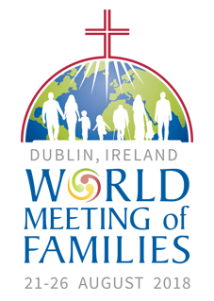

**World Meeting of Families – Mass Times – Sunday 26th August**

**Clonskeagh Parish - 9am *(**Please note change of Mass time for this day**)***

**Milltown Parish - 10am, 11.30am & 5.30pm**

**Dundrum Parish - 9am, 10.30 am & 12.00 noon**

**Special Invitation to view the Papal Mass at Three Patrons, Rathgar**

*To celebrate the arrival of Pope Francis, and to accommodate those who are unable to attend his Mass, we are arranging to have a screening in* ***St Patrick’s Hall of the Papal Mass on 26th August from 12.30pm****. As places are limited, we would ask those interested to give their name and phone number into the Parish Office as soon as possible (Tel. 014972215).*

*All are welcome to attend; refreshments will be served by the hospitality team.*

Entrance Hymn

**Hail, Queen of heaven, the ocean star,**

**guide of the wanderer here below;**

**thrown on life’s surge,**

**we claim thy care;**

**save us from peril and from woe.**

**Mother of Christ, star of the sea,**

**pray for the wanderer, pray for me.**

**O gentle, chaste and spotless maid,**

**we sinners make our prayers**

**through thee;**

**remind thy Son that he has paid**

**the price of our iniquity.**

**Virgin most pure, star of the sea,**

**pray for the sinner, pray for me.**

***Memorial Acclamation***

**We proclaim your Death, O Lord, and profess your Resurrection**

**until you come again.**

**Final Hymn**

**Be thou my vision,**

**O Lord of my heart,**

**naught be all else to me,**

**save that thou art:**

**thou my best thought in the day**

**and the night,**

**waking and sleeping,**

**thy presence my light.**

**High King of heaven,**

**when victory is won,**

**grant heaven’s joy to me,**

**O bright heav’n’s sun:**

**Christ of my own heart,**

**whatever befall,**

**still be my vision,**

**O Ruler of all.**

*“The strength of the family lies in its capacity to love and to teach how to love. For all a family’s problems, it can always grow, beginning with love”*

*Pope Francis, Amoris Laetitia*

**A FEW WORDS FROM FR. JOE………………………………**

Along with almost a million others I was in the Phoenix Park in 1979 for the Papal Mass and I hope to be there again next Sunday. A week later I went into Clonliffe College and began to study for the priesthood. In 1979 there were 100 students in Clonliffe and 18 in my class, well 17 really as one guy left on the first day! From then until now we have been living in a church which changes slowly as we are growing older in a rapidly changing culture.

The whole experience of facing the revelations of clerical sexual abuse has been a very difficult part of these past 40 years. It has taken courage and resilience for victims and survivors to tell their stories, for journalists and commentators to communicate their experience, for the makers of T.V. and radio programme to dramatise this in documentaries that shocked and upset us all.

The State has had its various enquiries and their findings have revealed generations of dysfunction that revolt, shock and sadden all who read them. The men who hold high office in the Church have struggled to communicate their understanding of this problem and their strategy for dealing with it to both the church and the secular world. While huge strides have been taken to make our parishes a safer place for children and there seems to be very few new allegations it doesn’t seem to be a problem that we can master. Someone likened it to a toothache, if one tooth is rotten the whole mouth suffers pain and the person suffering isn’t going to be happy again, or able to live normally until that tooth is extracted or sorted.

Pope Francis ultimately is the man in charge of the policy and procedures of the Church, its laws and actions and hopefully he can address the institutional responsibility and management of abuse while he is here with us. It seems that saying sorry isn’t enough, meeting victims and survivors certainly helps, but there has to be more. There was incredible hope, optimism and joy in 1979, lets pray that we can recover some of that energy, be renewed in our faith and revitalised in living and sharing the Gospel with a world that needs that Spirit filled message so much.

cross

*We prayerfully remember**all who are* ***Recently Deceased*** *and those whose* ***Anniversaries*** *occur at this time.*

***“May they rest in peace. Amen.”***

**“Be strong and take heart, all you who hope in the LORD”**

**Psalm 1:24**

**Relics of Saints Louis and Zélie Martin and Saint Thérèse of Lisieux**

The relics of Saints Louis and Zélie Martin, and their youngest daughter, Saint Thérèse, have come from Lisieux to Ireland to coincide with the World Meeting of Families 2018.

*The Relics will visit the Carmelite Monastery, Roebuck Road, Tuesday 21st August from 10.00 am—2.00 pm. All are welcome.*