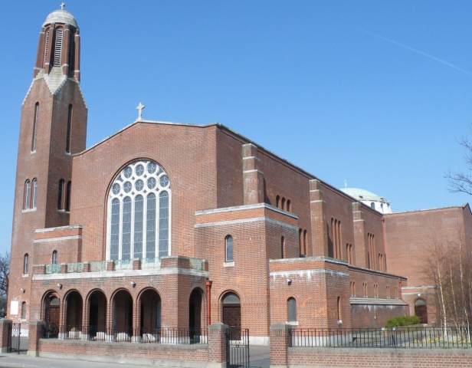

**Entrance**

Christ be near at either hand,

Christ behind, before me stand,

Christ with me where ere I go,

Christ around, above, below.

Christ be in my heart and mind,

Christ within my soul enshrined.

Christ control my wayward heart.

Christ abide and ne’er depart.

Christ my life and only way, Christ my lantern night and day.

Christ be my unchanging friend, Guide and shepherd to the end.

**Final**

Hail, glorious Saint Patrick, dear saint of our isle.

On us thy poor children bestow a sweet smile;

and now thou art high in thy mansions above,

on Erin’s green valleys look down in thy love.

Ever bless and defend the dear land of our birth,

where the shamrock still blooms as when thou

were on earth.

Our hearts shall yet burn wheresoever we roam,

for God and St. Patrick

and our native home.

**Confirmation Celebrations**

The children from **St. Kilian’s Deutsche Schule** received the **Sacrament of Confirmation** here in the Church on Saturday, 10th March. **Archbishop Diarmuid Martin D.D.** was Celebrant on this occasion.

*We* ***thank*** *the teachers and staff of St. Kilian’s Deutsche Schule for all their work in preparing the young candidates for this day.*

‘Come, Holy Spirit, fill the hearts of your Faithful.’



**CROSSCARE YOUTH SERVICES**

The Annual collection on behalf of **CROSSCARE YOUTH SERVICES** will take place *this weekend* ***17-18 March*.** This collection will be crucial in allowing Crosscare to continue to provide the best services for young people in our Diocese.

*Please continue to support* CROSSCARE YOUTH SERVICES.

**Parish News & Announcements:**

**Special Notice for Mass in Clonskeagh**

As and from this coming **Monday, 20th November**, 10am **Mass will be celebrated in St Joseph's every** **Monday** **to** **Saturday** **morning** (except for funerals).

Entrance will only be through the main church as the door at St Joseph's will be closed to keep out drafts and preserve the heat.

**Let us remember those who are housebound and listening to our Parish Mass on the Parish Radio today!**

Clonskeagh Parish   
Newsletter

© Redemptorist Communications,

**Diary for this Week:**

**Saturday 17 March – Fifth Sunday of Lent**

* ***6.30pm Vigil Mass for Special Intention***

**Sunday 18 March –Fifth Sunday of Lent**

* ***10.30am Mass for Teresa English & Angela Markey (Anniversary)***

**Monday 19 March – St. Joseph, Husband of the Blessed Virgin Mary**

* ***11am Mass for Pat Connolly (Anniversary)***

**Tuesday 20 March – 5th Week in Lent**

* ***10am Mass for Robin Corcoran (Recently Deceased)***

**Wednesday 21 March – 5th Week in Lent**

* ***10am Mass for Special Intention***
* ***Cup of Tea & ‘Sing Song’ after Mass. All welcome!***

**Thursday 22 March – 5th Week in Lent**

* ***10am Mass for Annie Hand (Recently Deceased)***

**Friday 23 March – 5th Week in Lent**

* ***10am Mass***
* ***Cup of Tea for all in St. Joseph’s after Mass. All welcome!***
* ***7.30pm Stations of the Cross***

**Saturday 24 March** – **5th Week in Lent**

* ***10.00am Mass***

**Thought for the Day**

In Italian, Lent is quaresima or forty (days). In German, it is Fastenzeit or time for bodily restraint. Our English word comes from an older Anglo-Saxon word for spring—len(c)ten— whence our Lent. Italian tells us how long it will last (with its symbolic overtones). German tells us what to do in that time. But English tells us what is supposed to happen, that is, we are supposed to experience a springtime of faith, a time growth and new life

*Let us Pray…*

*God of new life, bless us on our pilgrim way towards the great feast of Easter. Help us to know our need of your presence, breath your Spirit into our reading of the Word, teach us to set aside whatever hinders our true discipleship so that we may come to life in abundance and know in our hearts the joy of the Gospel.*

*Amen.*

**“Be strong and take heart, all you who hope in the LORD”**

***Psalm 1:24***

*We extend our sympathy to the families of*

***Tommy Dolan &******John Shorten***

*whose funerals were held in the church during the week.*

*We also prayerfully remember**all who are*

***Recently Deceased*** *and those whose* ***Anniversaries*** *occur at this time.*

***“May they rest in peace. Amen.”***

**

**The Season of Lent**

*‘Lent is a season of* ***Fasting, Prayer****, and* ***Alms Giving*** *in preparation for the joy of Easter’*

* **Alms Giving** -Trocaire once again invite us to join in with their Lenten Campaign.

The Trocaire packs are available at the back of the church. *All families in the parish are encouraged to take the pack from the back of the church and join in the Lenten Campaign.*

**2018 Archdiocese of Dublin Annual Knock Pilgrimage**

The Diocesan Pilgrimage to Knock will take place on *Saturday 21st April 2018*, with the main celebration of the Eucharist in the Basilica at 3pm.

This year’s theme: ‘*We are Pilgrims – Knock invites us to healing and Peace.’*

More information: [www.dublindiocese.ie/2018-diocesan-pilgrimage-to-knock](http://www.dublindiocese.ie/2018-diocesan-pilgrimage-to-knock/)

**Parish Office Notice**



**The Parish Office will open on Thursday from 9.30am until 12.30pm.**

***If you need to contact the parish office please do so via email:*** [***parishofficelonskeagh@eircom.net***](mailto:parishofficelonskeagh@eircom.net)

**Advocate Collection**

The annual *Advocate collection for the Sunshine Fund* takes place *on Saturday* *24th and Sunday 25th March*.

Your generosity would be greatly appreciated.

**Weekend Church Collections**

***1st Collection***

***(Support of the Priests) €415***

***2nd Collection***

***Share €340***

***House to House €350***

***Thank you for your continued support***.