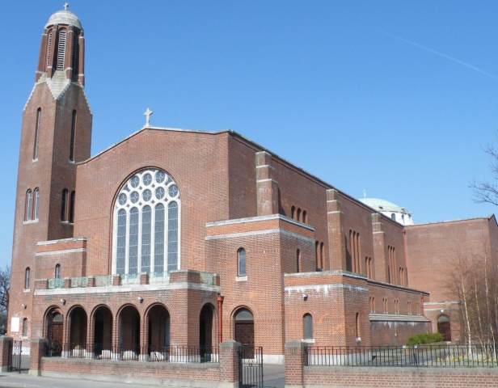



**CROSSCARE YOUTH SERVICES**

The Annual collection on behalf of **CROSSCARE YOUTH SERVICES** will take place *next weekend* ***17-18 March*.**

This collection will be crucial in allowing Crosscare to continue to provide the best services for young people in our Diocese.

*Please continue to support* CROSSCARE YOUTH SERVICES.

**Beannachtai na Feile Padraig!**

Patrick preached and converted all of [Ireland](http://www.catholic.org/encyclopedia/view.php?id=6170) for 40 years. He worked many miracles and wrote of his love for [God](http://www.catholic.org/encyclopedia/view.php?id=5217) his “Confessions”. After years of living in poverty, travelling and enduring much suffering he died March 17, 461.

**Why a shamrock?**

Patrick used the shamrock to explain the Trinity, and has been associated with him and the Irish since that time.

**In His Footsteps:** Patrick was a humble, pious, gentle man, whose love and total devotion to and trust in [God](http://www.catholic.org/encyclopedia/view.php?id=5217) is a shining example to each of us. He feared nothing, not even death, so complete was his trust in God, and of the importance of his mission to the Irish.

**MASS TIMES FOR THE FEAST OF ST. PATRICK**

***Friday 16 March – 6.30pm Vigil of St. Patrick’s Day***

***Saturday 17 March – 10.30am Mass St. Patrick’s Day***

**Entrance**

Praise to the Lord, the Almighty, the King of Creation.

O my soul, praise him,

For he is your health and salvation.

All you who hear,

now to his altar draw near, join in profound adoration.

Praise to the Lord, O let all that is in us adore him.

All that has life and breath, come now in praises before him.

Let the ‘Amen’ sound from his people again,

now as we worship before him.

**Final**

Make me a channel of your peace, where there is hatred, let me bring your love.

Where there is injury, your pardon Lord, and where there’s doubt, true faith in you.

Make me a channel of your peace. Where there’s despair in life, let me bring hope.

Where there is darkness only light and where there’s sadness, ever joy.

*Refrain*

*O Master, grant that I may never seek, so much to be consoled as to console.*

*To be understood as to understand, to be loved as to love with all my soul.*

Make me a channel of your peace.

It is in pardoning that we are pardoned.

In giving to all men that we receive,

and in dying that we’re born to eternal life.

**Parish News & Announcements:**

**Special Notice for Mass in Clonskeagh**

As and from this coming **Monday, 20th November**, 10am **Mass will be celebrated in St Joseph's every** **Monday** **to** **Saturday** **morning** (except for funerals).

Entrance will only be through the main church as the door at St Joseph's will be closed to keep out drafts and preserve the heat.

**Let us remember those who are housebound and listening to our Parish Mass on the Parish Radio today!**

Clonskeagh Parish   
Newsletter

© Redemptorist Communications,

**Diary for this Week:**

**Saturday 10 March – Fourth Sunday of Lent**

* ***6.30pm Vigil Mass for Mary & George Begley (Anniversary)***

**Sunday 11 March –Fourth Sunday of Lent**

* ***10.30am Mass Patrick McNulty & John Cullen and Tom & Noni Faherty (Anniversary)***

**Monday 12 March – 4th Week in Lent - The Novena of Grace concludes today**

* ***10am Mass for Special Intention***

**Tuesday 13 March – 4th Week in Lent**

* ***10am Mass for Annie Hand (Recently Deceased)***

**Wednesday 14 March – 4th Week in Lent**

* ***10am Mass for Special Intention***

**Thursday 15 March – 4th Week in Lent**

* ***10am Mass for Eileen McCann (Recently Deceased)***

**Friday 16 March – 4th Week in Lent**

* ***10am Mass for Dermot Costelloe (Recently Deceased)***
* ***Cup of Tea for all in St. Joseph’s after Mass. All welcome!***

**Friday 16 March - *Vigil of St. Patrick’s Day***

* ***6.30pm Mass for Special Intention***
* ***Please note that there will be no Stations of the Cross this evening***

**Saturday 17 March** – **4th Week in Lent – St. Patrick’s Day**

* ***10.30am Mass for Christy Thompson (Anniversary)***

**The Season of Lent**

*‘Lent is a season of* ***Fasting, Prayer****, and* ***Alms Giving*** *in preparation for the joy of Easter’*

* **Fasting** *–* “This is the fast that pleases Me – to break unjust fetters” *(Joel)*
* **Prayer -** On **Fridays** at **7.30pm** there will be Lenten Stations of the Cross
* **Alms Giving** -Trocaire once again invite us to join in with their Lenten Campaign.

The Trocaire packs are available at the back of the church. *All families in the parish are encouraged to take the pack from the back of the church and join in the Lenten Campaign.*

cross

**Thought for the Day**

What does it mean to be saved? We have the secular sense of being rescued or spared somehow. The root meaning of the word in Greek and Latin is to be healed. So, the beginning is some recognition of need, of something fractured, unwell in my life. It includes faith in God who wants us to be both whole and holy, fully alive. The big “sickness” is death itself— from which we are saved/healed through God’s love to us in the lifting up of Jesus in death into resurrection.

*Let us Pray…*

*Heavenly physician, heal whatever is us is dead or wounded or unfree that we may know the wholeness, freedom, life and joy of the Gospel.*

*Amen.*

**Parish Office Notice**



**The Parish Office will open on Thursday from 9.30am until 12.30pm.**

***If you need to contact the parish office please do so via email:*** [***parishofficelonskeagh@eircom.net***](mailto:parishofficelonskeagh@eircom.net)

**Weekend Church Collections**

***1st Collection***

***(Support of the Priests) €280***

***2nd Collection***

***Share €190***

***House to House €250***

***Thank you for your continued support***.

**“Be strong and take heart, all you who hope in the LORD”**

***Psalm 1:24***

*We extend our sympathy to the families of* ***Patrick Browne & Olive Copeland*** *whose funerals were held in the church during the week.*

*We also prayerfully remember**all who are*

***Recently Deceased*** *and those whose* ***Anniversaries*** *occur at this time.*

***“May they rest in peace. Amen.”***