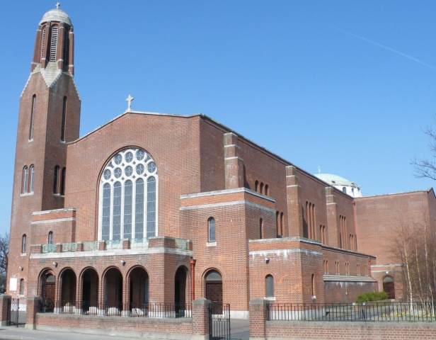

**Parish Office Notice**



**The Parish Office will open on Thursday from 9.30am until 12.30pm.**

***If you need to contact the parish office please do so via email:*** [***parishofficelonskeagh@eircom.net***](mailto:parishofficelonskeagh@eircom.net)

**Thank You from Fr. Jerry**

I wish to express my deep gratitude to all of you here for kindness

shown to me and your deep faith expressed.

You’re an inspiration to all. I'm just beginning a 30 day retreat ...silent!!! I will be thinking of you .... love to all .......Jerry

**Parish News & Announcements:**

**Special Notice for Mass in Clonskeagh**

As and from this coming **Monday, 20th November**, 10am **Mass will be celebrated in St Joseph's every** **Monday** **to** **Saturday** **morning** (except for funerals).

Entrance will only be through the main church as the door at St Joseph's will be closed to keep out drafts and preserve the heat.

**Let us remember those who are housebound and listening to our Parish Mass on the Parish Radio today!**

Clonskeagh Parish   
Newsletter

© Redemptorist Communications,

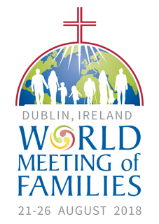

**What is World Meeting of Families?**

Dublin, Ireland, has been chosen by Pope Francis to host the next World Meeting of Families from 21-26 August 2018, guided by the theme *“The Gospel of the Family: Joy for the World”*.

The event has at its heart the following key moments:

**21 August 2018** –  [**National Opening of WMOF2018**](https://www.worldmeeting2018.ie/en-IE/Programme/Opening)

**22 to the 24 August 2018** – [**Three-day Congress**](https://www.worldmeeting2018.ie/en-IE/Programme/Congress)

**25 August 2018** –[**Festival of Families**](https://www.worldmeeting2018.ie/en-IE/Programme/Festival-of-Families)

**26 August 2018** – [**Solemn Eucharistic Celebration**](https://www.worldmeeting2018.ie/en-IE/Programme/Final-Mass)

*For more information:* [*www.worldmeeting2018.ie*](http://www.worldmeeting2018.ie)

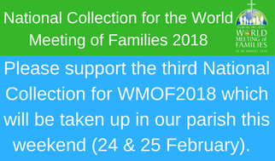



**St. Vincent de Paul Clothing Appeal**

The **annual appeal** for second-hand clothing will take place in our parish over the coming 2 weekends. The bags will be **distributed this weekend of 24/25 February** and next weekend, **3/4 March, the bags will be collected**.

*If you have any unwanted, clean clothes for charity this is a very worthy cause to donate them to.*



**Thought for the Day**

We live in a very noisy, busy world, a culture marked by constant distraction.

Even at the ordinary level of relationship, attending to the other — really hearing him or her — is a challenge.

It happens when we choose to make space, to shut out the other noises and graciously attend to each other. Something similar may be said of the life of the spirit.

To listen to the Son happens when we choose it and, in a practical way, create spaces in our lives for such encounters.

***Let us Pray…***

*Revealer God, you open your heart to us in your Son Jesus.*

*Help us to open our hearts to you, as we contemplate your living word. May the Scriptures be for us a place of true encounter and may we, hearers of the Word, listen with our hearts and lives to him, the Word made flesh. Amen*

**ALFIE LAMBE (*1932 – 1959)***



**Mass for the Beatification of Alfie Lambe**, one of Ireland’s candidates for sainthood will be offered in the **Church of The Three Patrons**, **Rathgar,** on **Sunday, 25 February, at 12 noon.**

*(Arranged by the Legion of Mary.)*

**Diary for this Week:**

**Saturday 24 February – Second Sunday of Lent – WMOF 2018 Collection**

* ***6.30pm Vigil Mass for Pat Hynes (Anniversary)***

**Sunday 25 February – Second Sunday of Lent – WMOF 2018 Collection**

* ***10.30am Mass for Martin Leonard (1st Anniversary)***

**Monday 26 February – 2nd Week in Lent**

* ***10am Mass for Des & Sean Keogh (Anniversary)***

**Tuesday 27 February – 2nd Week in Lent**

* ***10am Mass for Annie Hand (Recently Deceased)***

**Wednesday 28 February – 2nd Week in Lent**

* ***10am Mass for Edward & Ellen Kenny (Anniversary)***
* **Cup of Tea & A ‘Sing-Song’ for all in St. Joseph’s after Mass. *All welcome!***

**Thursday 1 March – 2nd Week in Lent**

* ***10am Mass for Pearl McGuinness (Recently Deceased)***

**Friday 2 March – 2nd Week in Lent – 1st Friday**

* ***10am Mass for Altar List of the Dead***
* ***Cup of Tea for all in St. Joseph’s after Mass. All welcome!***
* ***7.30pm Stations of the Cross***

**Saturday 3 March** – **2nd Week in Lent**

* ***10am Mass for Annie Hand (Recently Deceased)***

**Entrance**

Longing for light we wait in darkness. Longing for truth, we turn to you.

Make us your own, your holy people, light for the world to see.

Christ, be our light! Shine in our hearts, Shine through the darkness.

Christ, be our light! Shine in your church gathered today.

Longing for peace, our world is troubled.

Longing for hope, many despair.

Your word alone has power to save us.

Make us your living voice.

**Final**

The Bells of the Angelus are calling to pray,

In sweet tones announcing the sacred Ave.

*Refrain: Ave, Ave, Ave Maria, Ave, Ave, Ave Maria.*  
  
An angel of mercy, led Bernadette's feet,

Where flows the deep torrent,

Our Lady to greet

She prayed to our mother that God’s will be done;

She prayed for his glory that his kingdom come.

cross

**“Be strong and take heart, all you who hope in the LORD”**

***Psalm 1:24***

*We extend our sympathy to the family of* ***Richard Raymond*** *whose funeral was held in the church during the week.*

*We prayerfully remember* ***Miriam Hegarty & Thomas Clarke*** *whose anniversaries occur at this time.*

*We also prayerfully remember**all who are*

***Recently Deceased*** *and those whose* ***Anniversaries*** *occur at this time.*

***“May they rest in peace. Amen.”***



**Thank You**

The Annual Collection for ACCORD the Diocesan Agency for Marriage and the Family, was be taken up at all Masses last weekend. ***The total amount realised was €620.***

Thanks to all who contributed so generously.

**Weekend Church Collections**

***1st Collection***

***(For the support of the Priests) €595***

***2nd Collection***

***(ACCORD) €620***

***House to House***

***(Planned Giving Envelopes) €410***

***Thank you for your continued support***.