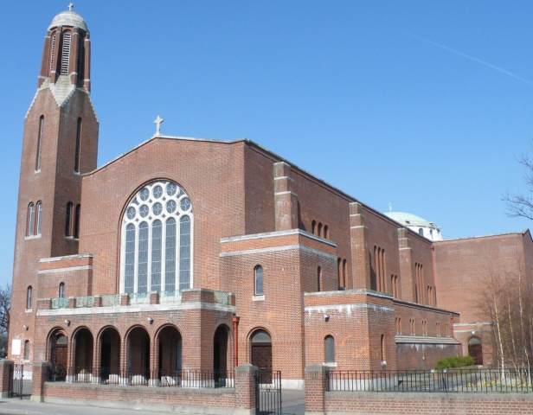



**ACCORD Annual Collection**

The Annual Collection for ACCORD the Diocesan Agency for Marriage and the Family,

will be taken up at all Masses this weekend - **17th &18th February 2018.**

**Message from Fr. Tony**

Over the past two years I have been very happy to meet with and share good memories with so many of the wonderful parishioners in this parish. However, I have also had to deal with a very difficult situation within the parish that I have tried hard to resolve.

I have come to the end of my ability to manage the situation and consequently I am stepping down from any involvement in the parish effective from 19th February 2018. I have informed the Archbishop of my decision.

I wish you my very best and my thanks to the parish secretary, Sylvia Leonard.

***Fr. Tony Coote***

**Parish News & Announcements:**

**Special Notice for Mass in Clonskeagh**

As and from this coming **Monday, 20th November**, 10am **Mass will be celebrated in St Joseph's every** **Monday** **to** **Saturday** **morning** (except for funerals).

Entrance will only be through the main church as the door at St Joseph's will be closed to keep out drafts and preserve the heat.

**Let us remember those who are housebound and listening to our Parish Mass on the Parish Radio today!**

Clonskeagh Parish   
Newsletter

© Redemptorist Communications,

**Parish Office Notice**



**The Parish Office will open on Thursday from 9.30am until 12.30pm.**

***If you need to contact the parish office please do so via email:*** [***parishofficelonskeagh@eircom.net***](mailto:parishofficelonskeagh@eircom.net)

**Diary for this Week:**

**Saturday 17 February – First Sunday of Lent - ACCORD Annual Collection**

* ***6.30pm Vigil Mass for Leo Larrigan (Anniversary) & Elizabeth (Lill) Webster (Month’s Mind)***

**Sunday 18 February – First Sunday of Lent - ACCORD Annual Collection**

* ***10.30am Mass for Deceased Members of the Keane Family (Anniversary)***
* ***Service of Light for this year’s Confirmation Candidates***

**Monday 19 February – 1st Week in Lent**

* ***10am Mass for Gerard Farrelly (Recently Deceased)***

**Tuesday 20 February – 1st Week in Lent**

* ***10am Mass for Annie Hand (Recently Deceased)***

**Wednesday 21 February – 1st Week in Lent**

* ***10am Mass Joe Whelan (Anniversary)***

**Thursday 22 February – The Chair of St. Peter, Apostle**

* ***10am Mass for Annie Hand (Recently Deceased)***

**Friday 23 February – 1st Week in Lent**

* ***10am Mass for Annie Hand (Recently Deceased)***
* ***Cup of Tea for all in St. Joseph’s after Mass. All welcome!***
* ***7.30pm Stations of the Cross***

**Saturday 24 February** – **1st Week in Lent**

* ***10am Mass for Ursula Deering (Recently Deceased)***

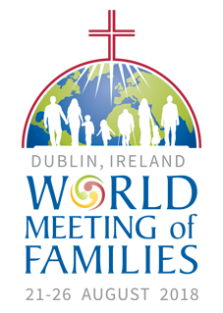

**What is World Meeting of Families?**

Dublin, Ireland, has been chosen by Pope Francis to host the next World Meeting of Families from 21-26 August 2018, guided by the theme *“The Gospel of the Family: Joy for the World”*.

The event has at its heart the following key moments:

**21 August 2018** –

[**National Opening of WMOF2018**](https://www.worldmeeting2018.ie/en-IE/Programme/Opening)

**22 to the 24 August 2018** –

[**Three-day Congress**](https://www.worldmeeting2018.ie/en-IE/Programme/Congress)

**25 August 2018** –

[**Festival of Families**](https://www.worldmeeting2018.ie/en-IE/Programme/Festival-of-Families)

**26 August 2018** –

[**Solemn Eucharistic Celebration**](https://www.worldmeeting2018.ie/en-IE/Programme/Final-Mass)

*For more information:* [*www.worldmeeting2018.ie*](http://www.worldmeeting2018.ie)

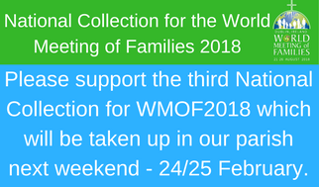

**Confirmation Mass**

On Sunday, **18th February**, we warmly welcome the **Confirmation Candidates** from St. Kilian’s Deutsche Schule. The Confirmation Candidates will celebrate their ‘Service of Light’.

The date for this year’s Confirmation Ceremony is: **10 March 2018 at 11am.**

We take this opportunity to wish them well and to assure them of our continued prayers as they continue their preparations for this very special day.

*‘Come, Holy Spirit, fill the hearts of your Faithful. Enkindle in them the fire of Your love.’*

cross

**ALFIE LAMBE (*1932 – 1959)***

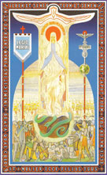

**Mass for the Beatification of Alfie Lambe**, one of Ireland’s candidates for sainthood will be offered in the **Church of The Three Patrons**, **Rathgar,** on **Sunday, 25 February, at 12 noon.**

*(Arranged by the Legion of Mary.)*

**Entrance**

Let us build a house

where love can dwell…

As previously.

Let us build a house

where prophets speak.

All are welcome, (2)

All are welcome

in this place.

**Final**

When creation was begun,

God has chosen

you to be mother of his blessed Son,

Ave Maria.

When creation was restored,

You were there

beside the Lord,

whom you cherished and adored.

Ave Maria.

*We extend our sympathy to the family of* ***Robin Corcoran*** *whose funeral was held in the church during the week.*

*We also prayerfully remember**all who are*

***Recently Deceased*** *and those whose* ***Anniversaries*** *occur at this time.*

***“May they rest in peace. Amen.”***

**“Be strong and take heart, all you who hope in the LORD”**

***Psalm 1:24***

**Weekend Church Collections**

***1st Collection***

***(For the support of the Priests) €540***

***2nd Collection***

***(SHARE Diocesan Admin) €495***

***House to House***

***(Planned Giving Envelopes) €340***

***Thank you for your continued support***.